QC Workflow for UAT:

The workflow:.

1. Search Resource carried out ICSF Review
2. Review Completed ICSFs are listed in Review Completed ICSF.
3. Search Resource selects a Review Completed ICSF for QC and selected a user as QC Reviewer.
4. The ICSF is listed in the QC Check page and can be opened by the designated QC Reviewer.
5. QC Reviewer adds comments against Findings inserted earlier by Search Resource and also add additional findings.
6. QC Reviewer submits the QC form (marked as QC Completed)
7. Search Resource opens the QC Form and provides responses.
8. When all the items are marked as ‘Corrections Completed’ or ‘Accepted’ the ICSF is marked as completed.

Changes related to QC Workflow:

1. Search Resource carried out ICSF Review
2. Review Completed ICSFs will appear in this page:

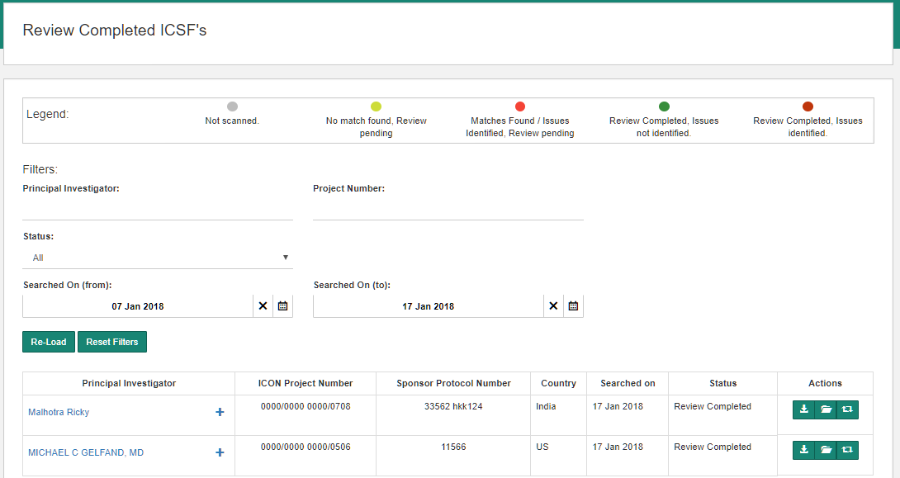

1. Search Resource requests for a QC

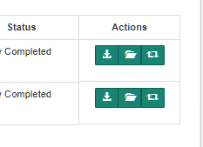

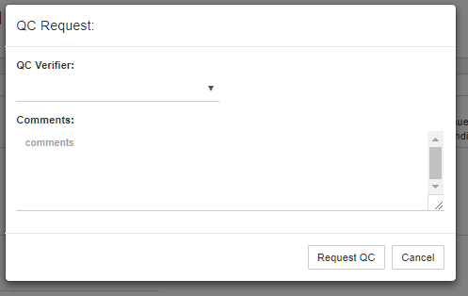

* 1. Compliance form is set to ‘QC Requested’ and cannot be modified. View is permitted.

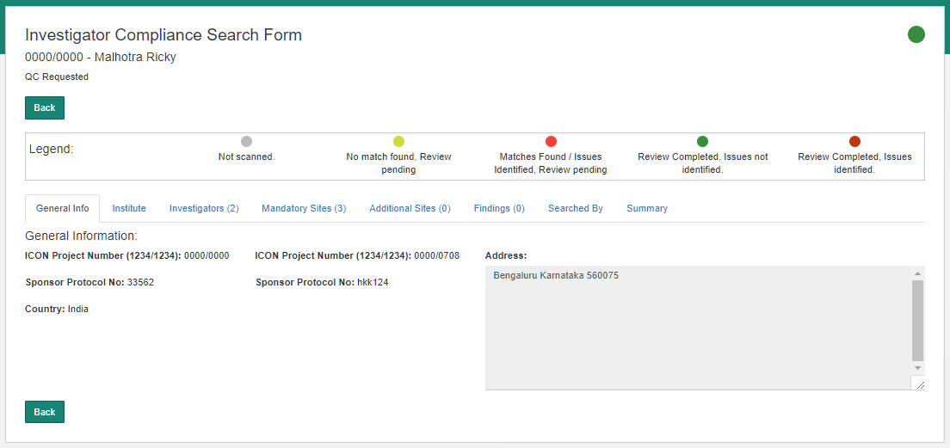

1. All ICSFs marked for QC are listed in the Quality Check page.
2. The Quality Check page as seen by User1 ( who has requested for QC)

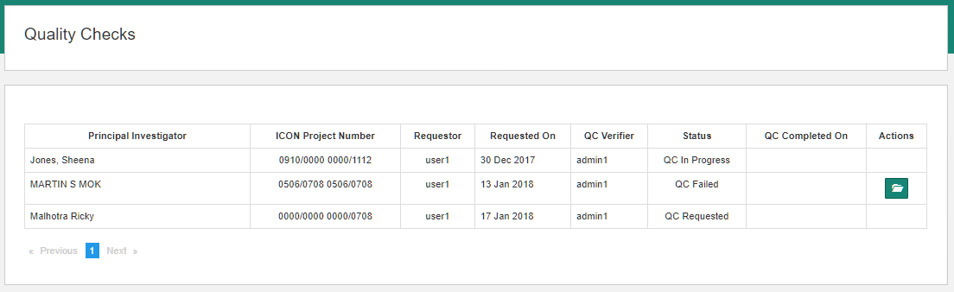

1. The Quality Check Page as seen by Admin1. User1 has requested Admin 1 to QC two ICSFs.

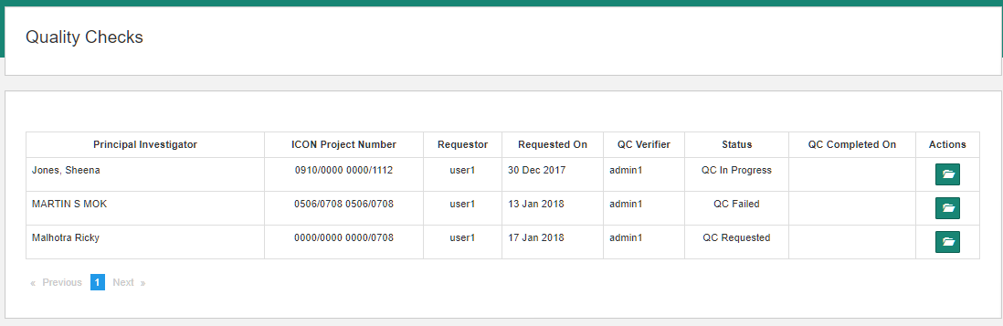

1. Admin1 (QC Verifier) starts QC Verification.

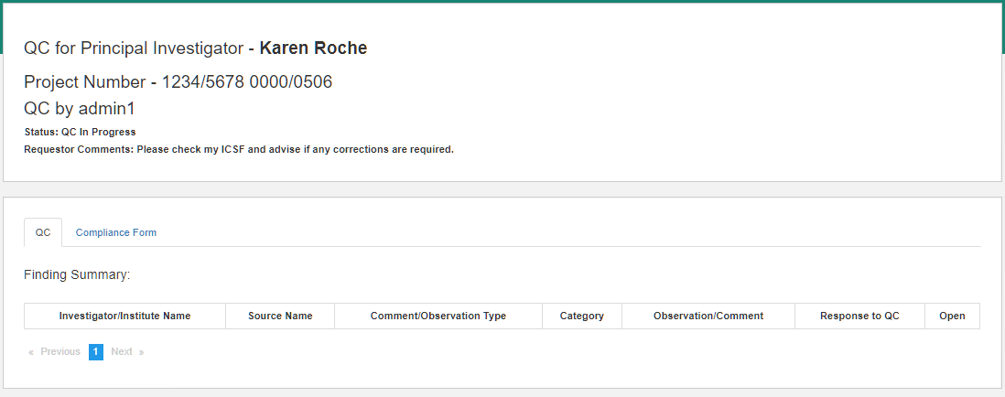

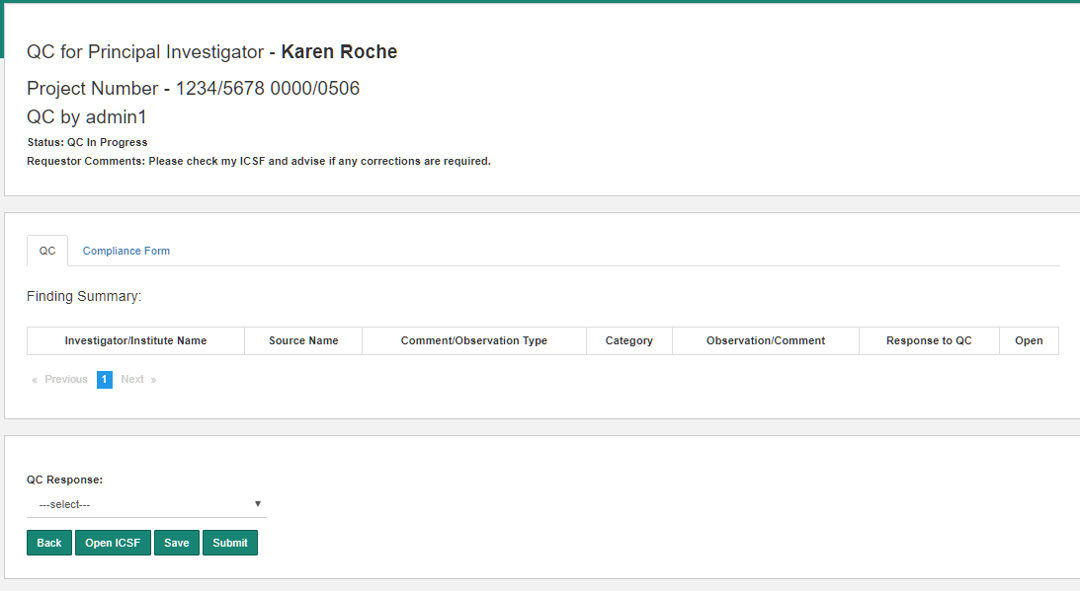

View ICSF – format similar to the generated ICSF word document:

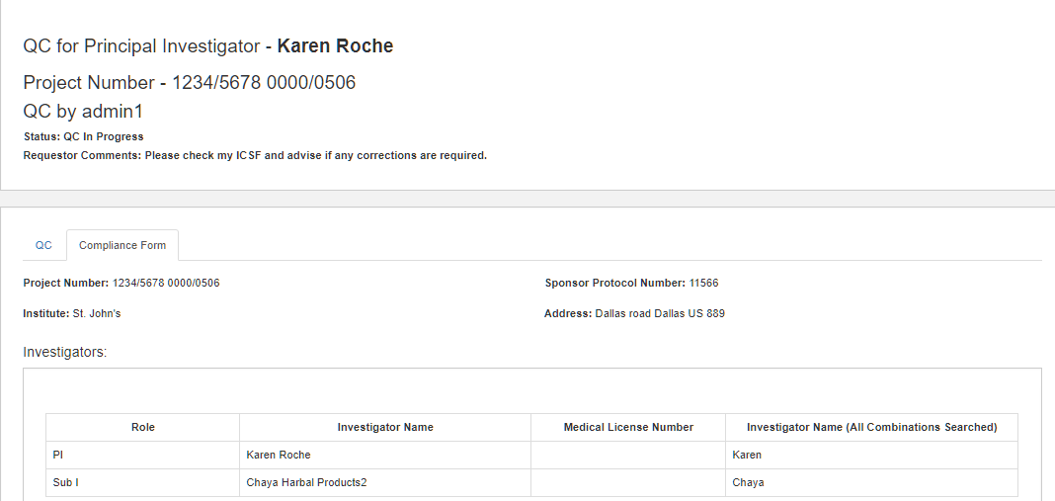

1. Open ICSF : Opens the Compliance Form



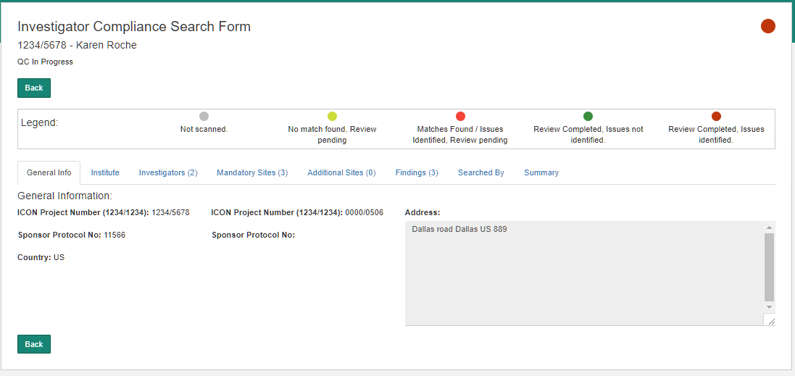

Note: ICSF Form does not permit modifications to input values.

Note: Allows Comments to Findings added by Search Resource.

1. QC Verifier Adds Comments …

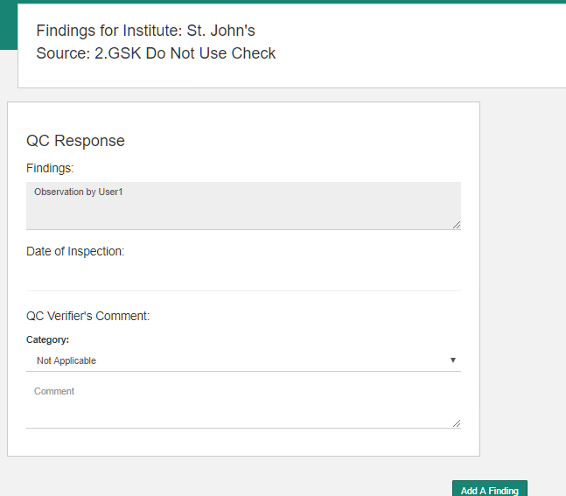

1. QC Verifier can also add an observation:

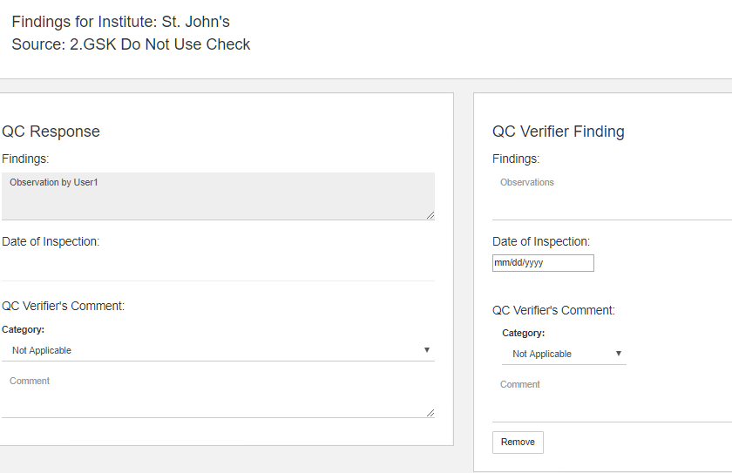

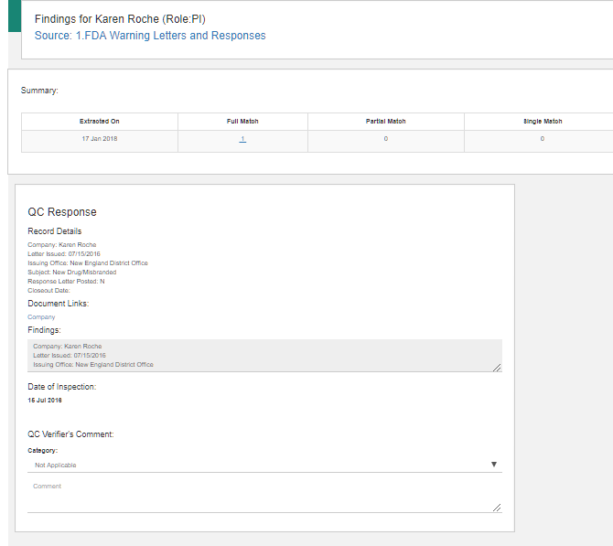

1. All the findings for which observations (marked as Minor, Major etc) are displayed in the QC Edit page.

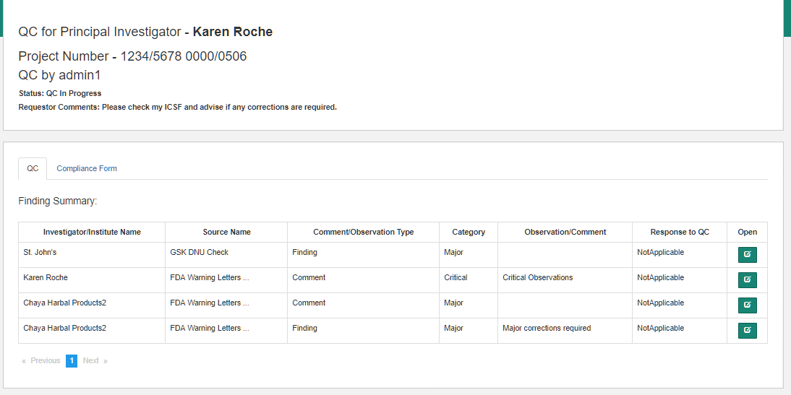

1. Modifications to the observations and Category (Minor, Major etc) can be made here.

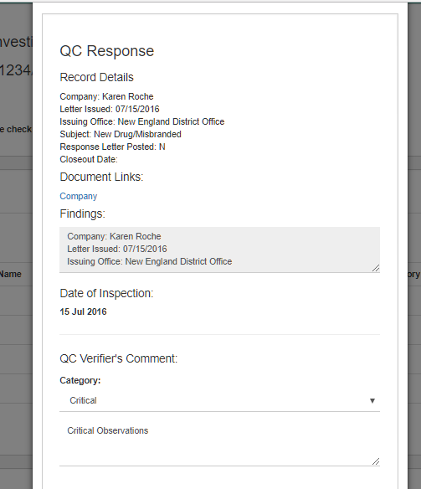

1. QC Reviewer submits the QC form (marked as QC Completed)
2. Search Resource opens the QC Form and provides responses.

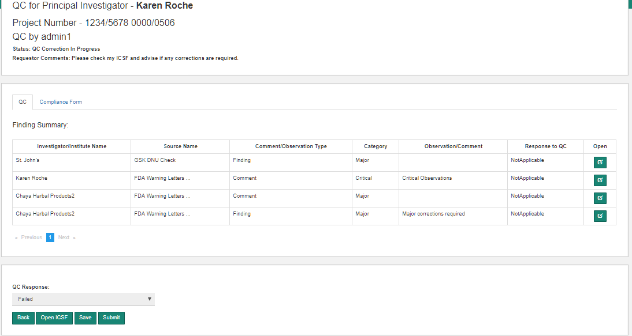

Response to QC Verifier Comments:

Comments on a Finding added by the Search Resource. The Search Resource makes corrections in the Finding and marks it as ‘Corrections Completed’

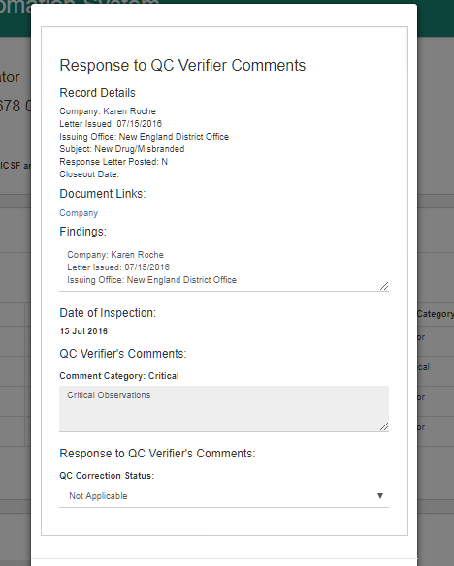

Finding added by the QC Verifier. The Search marks the Finding as ‘Accepted’

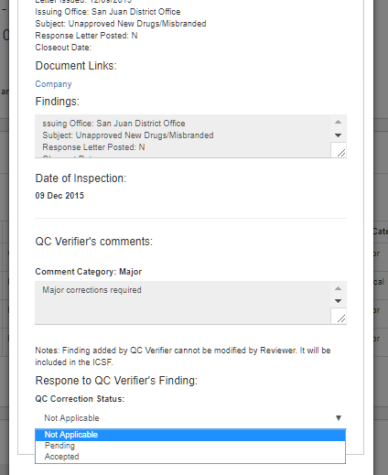

1. When all the items are marked as ‘Corrections Completed’ or ‘Accepted’ the ICSF is marked as completed.